SIMATS ENGINEERING
CSA6303- Threat Intelligence and Network Security
A3- Capstone Review – I
Assessment Questions
Subject | Threat Intelligence | Total Marks | 100
REg.No | 192365038 | Name | EPURU DHARMIK REDDY
Faculty | Dr.V.Parthipan | Slot | A
Co2: Identify common network attacks and analyze threat intelligence sources and data collection techniques.
Code of Conduct:

I EPURU DHARMIK REDDY (192365038) certify that this submission is my original work and that I have adhered to the guidelines specified for this assessment. I understand that any violation of academic integrity rules will result in disciplinary action.

Signature of Student : E.Dharmik Reddy

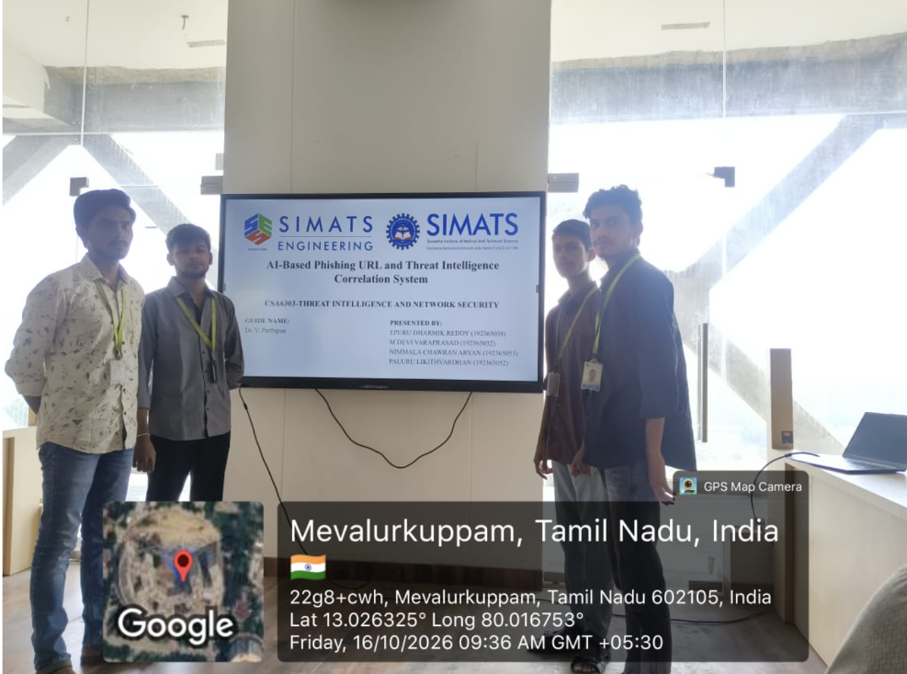

Presentation  10 | Technical skill& Objectives and scope  10 | Problem statement  10 | Technology stack  10 | Work plan  10 | Total  50

